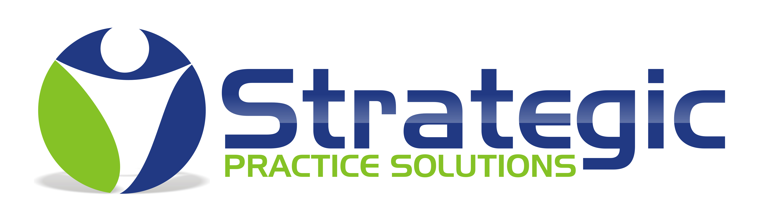 | Dental Auxiliary  Radiology Course  Macomb Dental Education Center
Did You Know?  Michigan Public Act No. R33811403 mandates that as of July 26, 1992, all auxiliary personnel must be formally trained in radiographic history and techniques in order to expose radiographs on patients. The law states that their education must be substantially equivalent to a college credit course.  This course, in cooperation with the Macomb Dental Society, has been designed to be substantially equivalent to the required education.  Who Is Exempt?  Registered Dental Assistants and Certified Dental Assistants who have completed an accredited college dental assisting program are not required to complete this course.  Faculty  All phases of the course are taught by licensed faculty, registered dental assistants, dental hygienist or dentist. References and credentials are available upon request.  Course Content – State of Michigan Guidelines  - Radiation Physics and Biology  - Radiation Health, Safety and Protection  - Film Exposure  - Processing Factors  - Intraoral and Extraoral Techniques  - Film Mounting  - Clinical Evaluation  - Didactic Exam  Certificate is awarded upon successful completion of the entire program. Late arrivals and early dismissals are NOT permitted.  Course Structure  This is a two day seminar. Day one is the lecture portion from 10:00am until 4:30pm. Day two is the clinical portion held from 10:00am until 1:30pm. We break for lunch at 12:30pm on Day One (on your own). Continental Breakfast provided on Day One, Pizza lunch provided on Day Two.  Limitations  - We cannot accept participants who are pregnant due to the nature of the practical training on radiographic equipment.  - Participants must have at least 3-6 months experience within a dental practice. Dental terminology is extremely important to achieve success in this seminar.  Please note:  Dress comfortably but modestly. Bring paper and pencil. Bring a laptop and course content will be available via flashdrive. Day one lunch break will be on your own.  Registration Details  Make checks payable to Strategic Practice Solutions. We also accept Visa or MasterCard. Payment Due at Registration. | Macomb Dental Education Center (MDEC) agree:  MDEC follows the ADA guideline of a 6/1 student to instructor ratio for clinical procedures. The MDEC further agrees to make available all written and classroom material as well as supply a Certificate of Completion to each participant if the following criteria are met:  - The student is at least eighteen (18) years of age.  - The student has had at least 3-6 months experience within a dental practice.  - The student must attend both entire sessions.  - Written examination is passed with 75% proficiency.  (Bring Printed exam as proof with you on day two. Verification on cell phone is unacceptable)  - Clinical examination is successful (clinical examination is pass or fail.)  - In order for participants to complete their radiology requirements; the student has to complete two full mouth series of radiographs (or the equivalent) on a patient of record. It will be the student’s responsibility to have this completed under the direct supervision of a licensed personnel. Please contact us if for any reason you are unable to meet this requirement.  Class Location- Multiple Locations  Day One: Strategic Practice Solutions, LLC  8187 Rhode Drive, Ste B. Shelby Twp., MI 48317  Phone: 888.421.1808  Day Two: Dr. Kachorek,  42490 Garfield, Suite 201, Clinton Twp., MI 48038  Phone: 586.630.4488  REFUND POLICY: We recognize that registrants may need to withdraw from a previously schedule course. Notification of withdrawal received five (working) days prior to the course will be accommodated. A credit voucher for a future Strategic Practice Solution course will be issued. No cash or credit refunds will be offered.  Release Form  I, the undersigned, hereby release the Macomb Dental Education Center, its faculty and any private facilitators from any and all liability, claims and/or lawsuits whatsoever, known or unknown, resulting from this course presented by Strategic Practice Solutions and the Macomb Dental Education Center. It is my understanding that students given this course are under the direct supervision of their employer during any dental radiographic or photographic procedure.
  Studen Name
  Phone:
  Student Signature:
  Dentist Signature:
  By signing above I understand and agree to the above terms or that the student will meet the terms listed in the Limitations and MDEC Agreement and Release Form Sections.
  Date:

